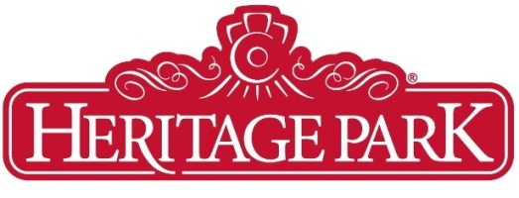
Ship’s Captain

Heritage Park is looking for an experience individual to join our team. Take the wheel of one of Park’s most iconic attractions as the Captain of the S.S. Moyie. Haul up the anchor and work in the fresh air of the quarterdeck, sailing the Calgary Glenmore Reservoir multiple times every day! Apply now for this exciting position and spend your summer on the water.
The Ship Captain ensures scheduled passenger service on the S.S. Moyie operates in a safe and efficient manner. Supervises staff and ensures the ship is operated in accordance with all government regulations and Heritage Park Policies.
This is an annual seasonal full-time position role that runs from May to September.

Duties and Responsibilities:
- Navigates the vessel in designated areas.
- Provides Customer service and information to passengers in a courteous and friendly manner, accepts tickets, and deals with any passenger enquiries/concerns.
- Maintains scheduled passenger service.
- Asses weather, vessel, and other conditions; Suspend service if passenger or vessel safety are at risk
- Ensures the vessel is properly maintained, serviced, and repaired in accordance with Department of Transport standards and regulations, and that the vessel successfully passes inspections.
- Assists in the selection of staff and evaluates aspects of their job performance as required.
- Ensures all pre and post season vessel preparations are completed.
- Schedules staff for private functions held on the vessel after regular Park hours.
- Provides support to the Reservoir Safety Patrol Boat by reporting unusual occurrences and specifying their location.

Education:
- Holds a Masters certificate of 150 tons or greater
- Completion of Secondary School
- Proof of training in relevant areas of seamanship
- Knowledgeable in Marine Safety Procedures

Experience:
Approximately three years of job-related experience. Is well versed and knowledgeable in the marine safety procedures.
Skills:
A valid driver's license is required.

Special Working Conditions:
The employee must be prepared to work in a variety of weather conditions. A considerable amount of walking, standing, and other physical duties are required in order to complete the work assigned. This position requires the person to be in good physical condition.

Hours of Work:
Work Schedule: maximum 5 days/week, and no more than 8 hours per day
Generally, the SS Moyie will sail 7 days per week during daylight hours; however, private or special event sailings may be booked in the evening hours or at night.

How to Apply:

Please submit a cover letter along with your resume to hr@heritagepark.ca, identifying the position for which you’re applying in the Subject Line. Feel free to include licenses and other relevant documentation.

HERITAGE PARK IS AN EQUAL OPPORTUNITY EMPLOYER. WE INVITE APPLICATIONS FROM ALL QUALIFIED INDIVIDUALS. WE VALUE DIVERSITY AND ARE COMMITTED TO PROVIDING AN INCLUSIVE CULTURE WHERE EVERY EMPLOYEE FEELS VALUED AND SAFE.

